Practical No. 3
Aim : 5) WAP to convert bits to megabytes, gigabytes and terabytes.

Name : Danish Altaf Solkar | Class : CO - B
Enrolment no. : 24111590805 | Batch : 2

Code :-
bits=float(input("\nEnter number of bits: "))
bytes=bits/8
megabytes=bytes/(1024*1024)
gigabytes=bytes/(1024*1024*1024)
terabytes=bytes/(1024*1024*1024*1024)
print("\n",bits," bits are equal to ",bytes," bytes")
print("\n",bits," bits are equal to ",megabytes," megabytes")
print("\n",bits," bits are equal to ",gigabytes," gigabytes")
print("\n",bits," bits are equal to ",terabytes," terabytes")

OUTPUT :-
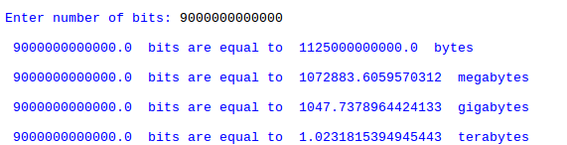

Process related  (30) | Product related  (20) | Total Marks  (50) | Signature

